Authentication and Authorization

Spis treści

Authentication and Authorization Basics 2

Definition 2

Adding Cookie Authentication 2

Login and Out 3

Cookie 4

External Identity Provider 5

Multiple identity providers 7

Implementing Auth wit Asp.Net Core Identity 9

Definition 9

Configuration 10

Managers 13

Working with claims 13

Roles 15

Email functionality 16

Two factor Auth 18

# Authentication and Authorization Basics

## Definition

Authentication is an access to application with login and register mechanic. Without authentication there is no authorization.

Autherization is access to particular operation in software.

## Adding Cookie Authentication



AddAuthentication in services with Default Cookie Auth

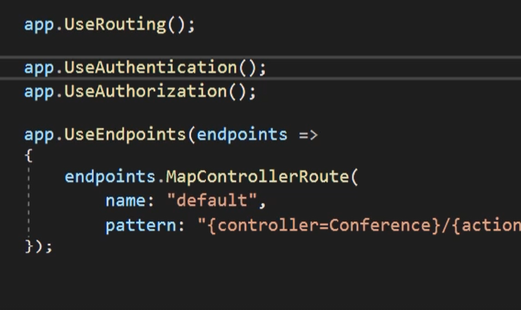

Then add authentication and authorization between routing and endpoint because this is pipeline when each element is added after the one before and order has matter. When dev adds a auth mechanism after endpoint then request will be send to customer without auth because is after endpoint.

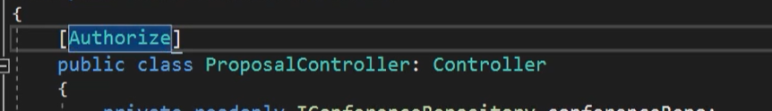

Basic filter of Auth is an Authorize. Users which aren’t authenticate doesn’t have access to controller.



To this filter can be added different polices roles and AuthSchemas.



Can be used on methods too.



Can be added as global auth, but always in app is views available to all user and available for specific type of user.

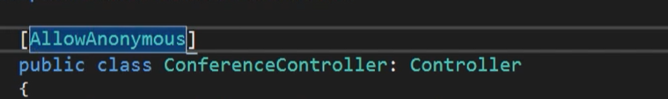

Is filter which give access to all user.

## Login and Out

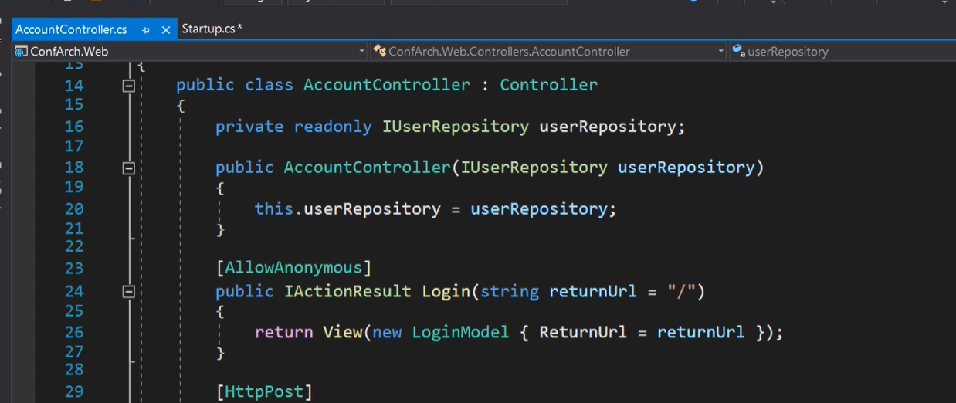

Create method in controller

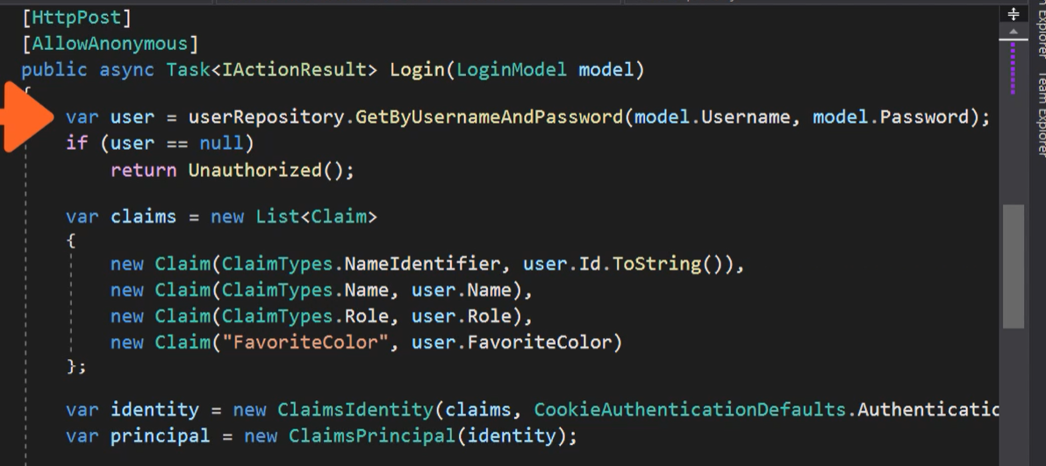

And post method. First part of code return user with specific username and password. Then is List of claims which is a state of entity which give acces to particular operation. There are two type of identityDB based on role or based on claim.

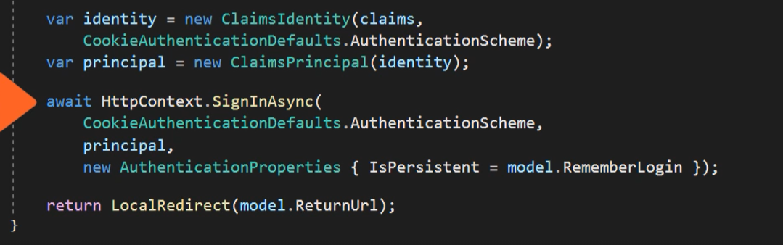

Then is a ClaimIdentity with claims and schema of auth. Principles is object represent users.  
SignIn method invoke from HttpContext object (session provider) need two params schema. Object with claims rules and AuthPropertis.

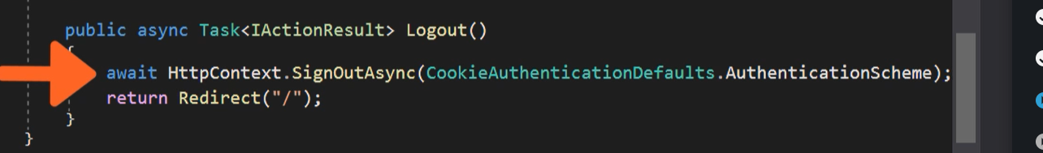

Logout is only method and redirect.

## Cookie

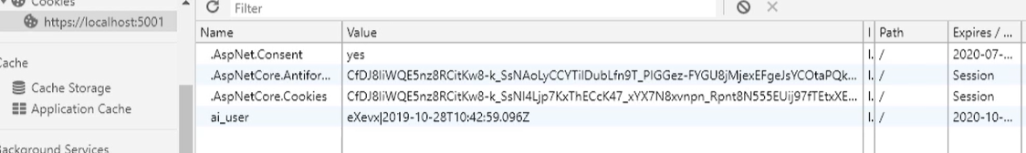

Identity cokkie has been created and sent to Browser. When user close browser still be login in with cookie. Cookie needs a expire time because user will be logged forever or to log out operation.

After Logout cookie disappear form browser.

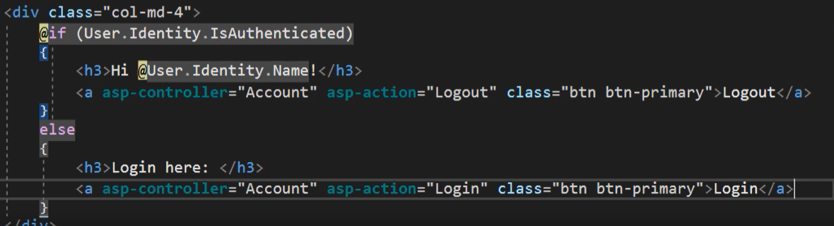

Saved claim give access to sate of objects.

## External Identity Provider

Cookies created by asp.net core identity is a internal provider. External is a 3rd part app like created by Facebook, Microsoft, Google which create token. This token will be process and after this operation based on Google token will be create identity cookie will sent to browser.

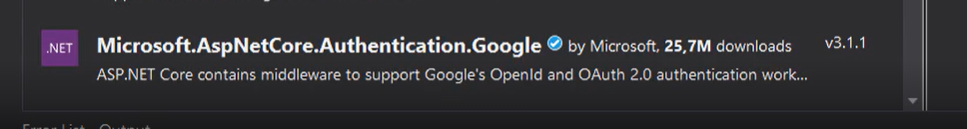

But to use external provider required is an package supported OpenId or OAuth 2.0

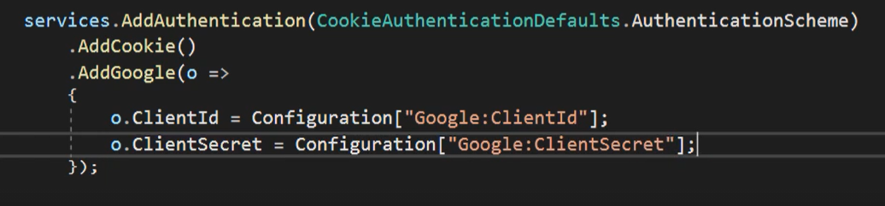

Then add service with options like id and secreat copied from Google’s site.

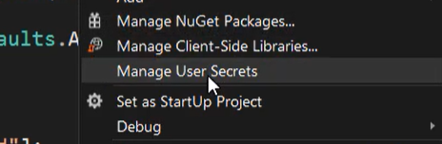

Add secret to json file

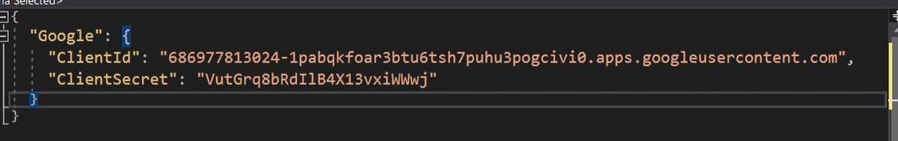

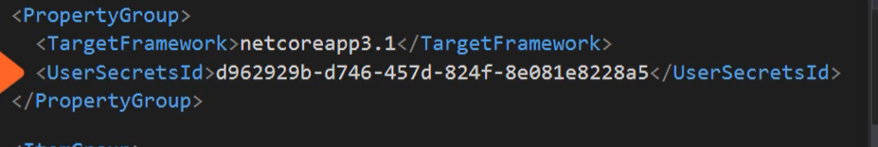

Or pasted to project file

Or

Create via CMD.

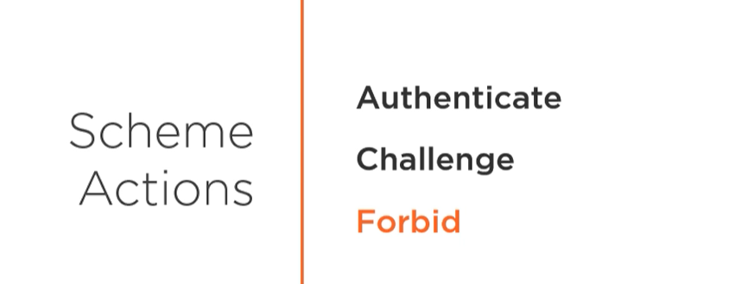Three action firt is login and logout. Second is redirect to login when user is not logged in. Third one is when user doesn’t have access to action.

With external provider you need to login providers website.

## Multiple identity providers

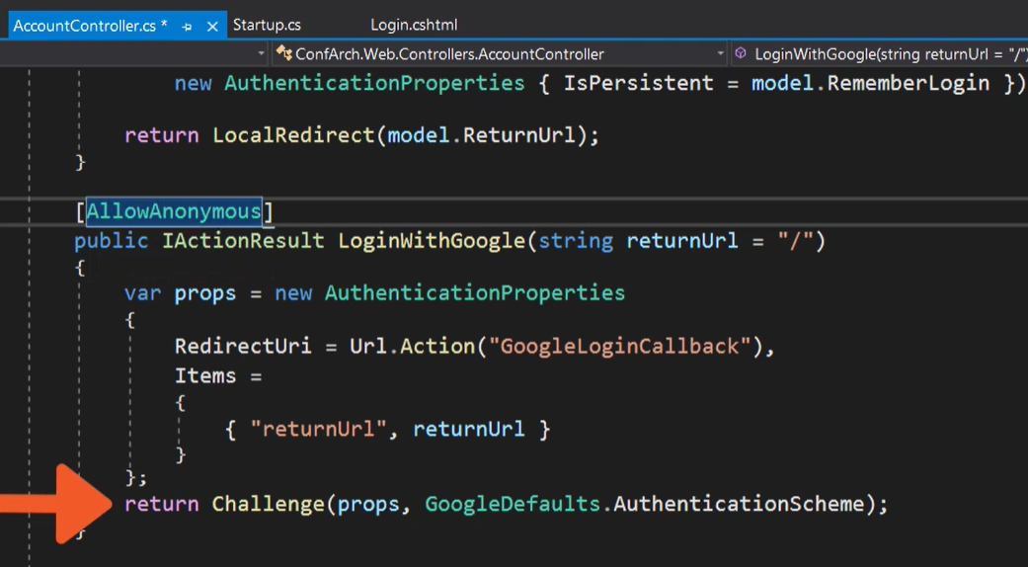

Create login action to external provider. Wit redirect to our app.

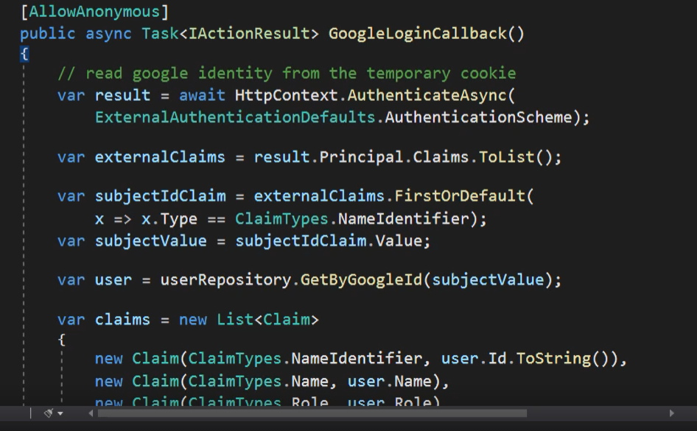

Create claims with post.

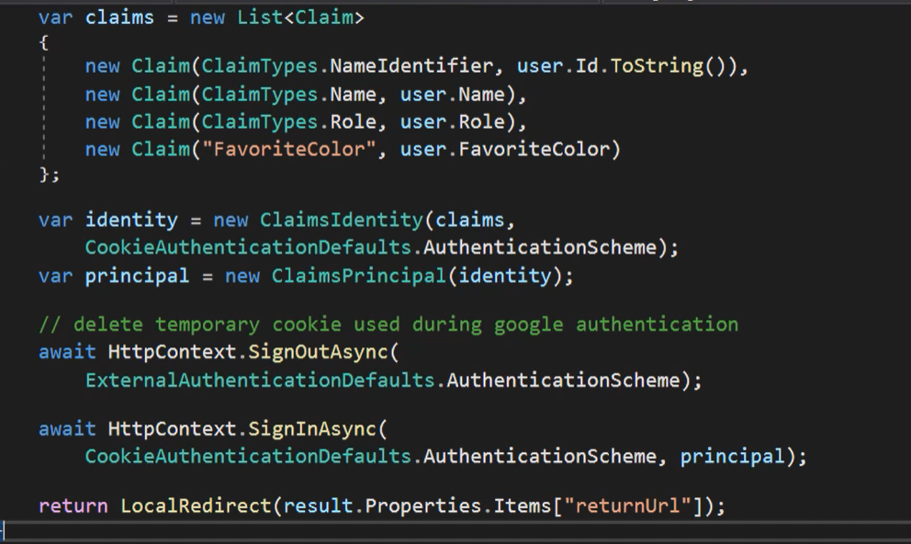

And rest of code like in internal provider.

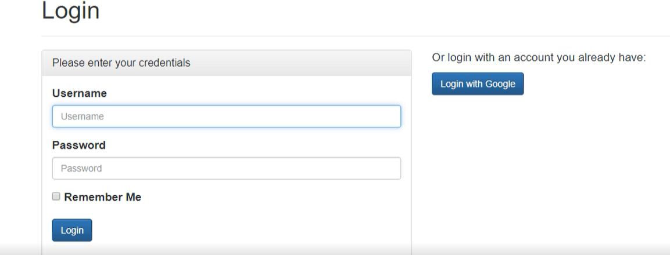

Now It’s both of providers.

# Implementing Auth wit Asp.Net Core Identity

## Definition

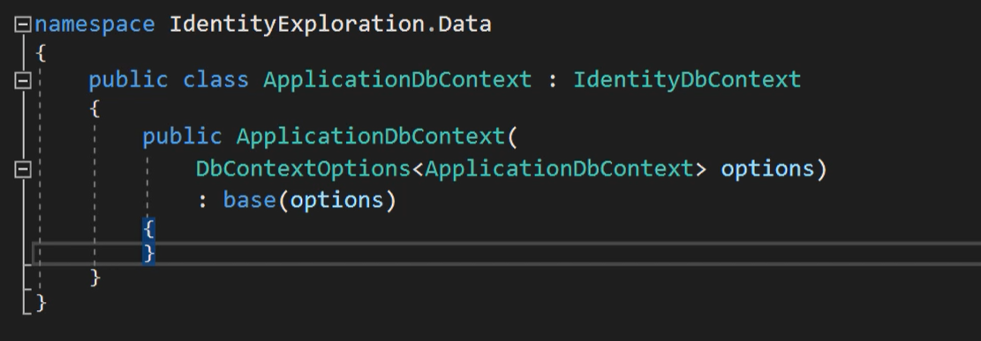

Do you know that? Don’t you? It’s the most uses identity. It is part of Microsoft aps.net core and can be added with one click when dev creates app.

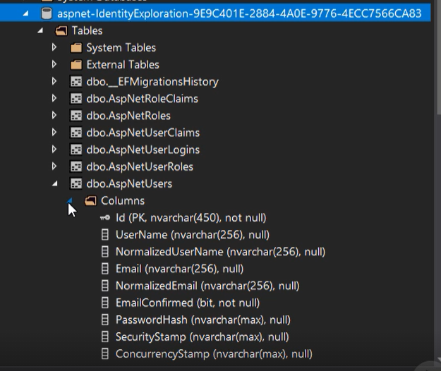

After migration and update db all tables from IdentityContext will be added.

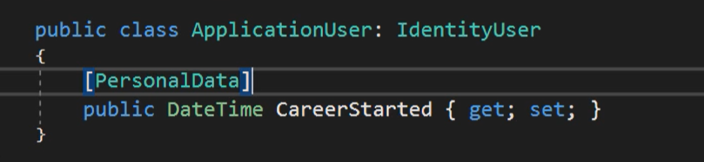

To extend ASpNetUSers table create AppliucationUser with inheritenced properties from IdentityUser class.

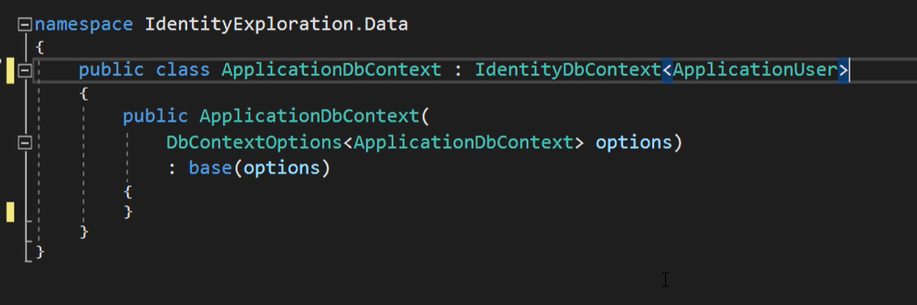

After that attach generics type param to DbContext and add migration and update db.

## Configuration

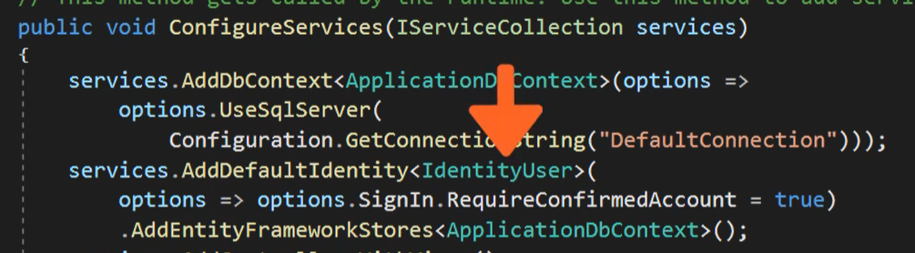

Configuration is added by default. But first method added DbContext. Second add default Indentiti and Framowork stores of course everything is related to DbContext with Identity.



But in our app DefaultIdentity is a Application user so change this code.

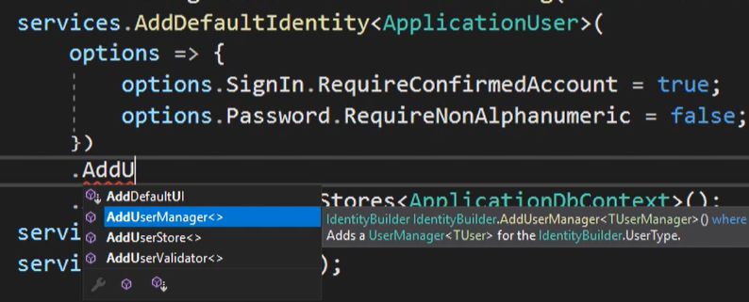

Options can configure everything which is related to Auth like password account confirmation, etc and of course to app can be added configured AddUserManager but of course is default version created by Ef Core Identity package.

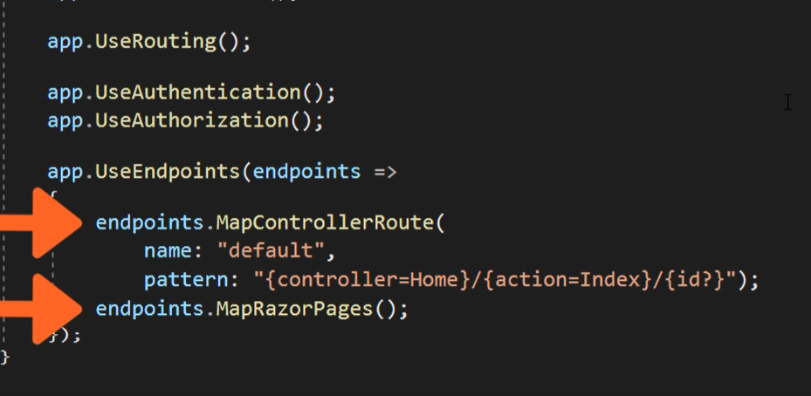

Add Auth in pipeline if is lack of, but of course is added by default.

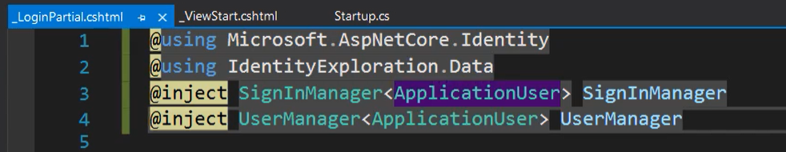

Change sign and user manager to our identity and save after that it can be login and regiseter view reached.

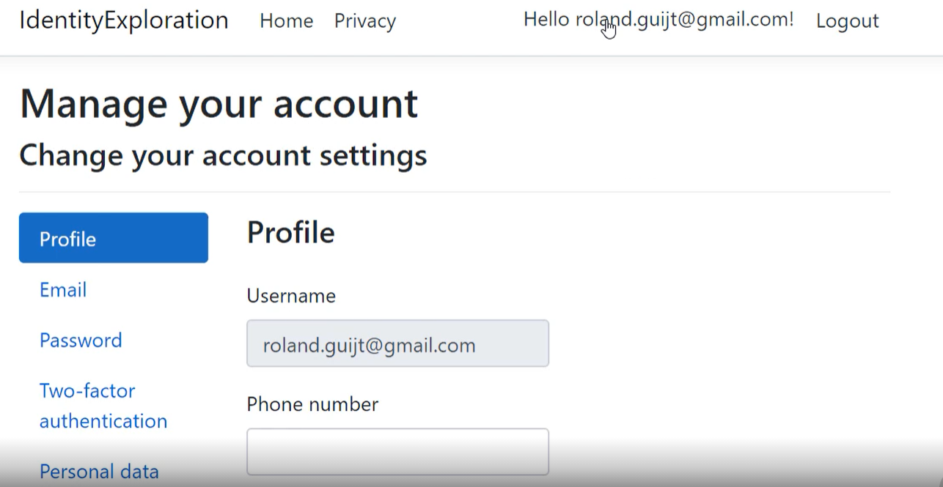

But of course view can be appear. Just add scaffolded item and choose identity and login and register part of razor page. View with code behind will be generated and it will be palaced in area folder. After that add service with razor pages.



## Managers

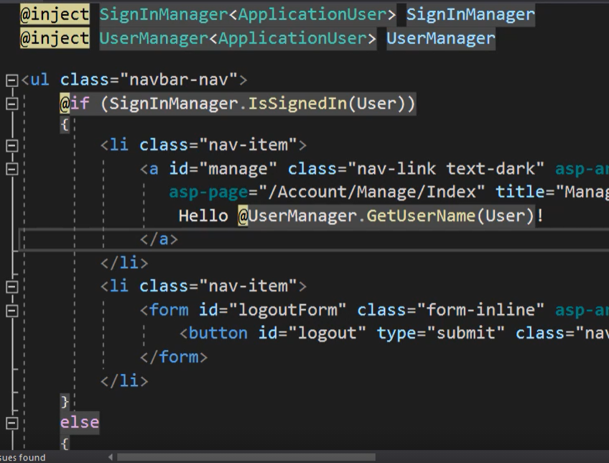

The have all information about session.

## Working with claims

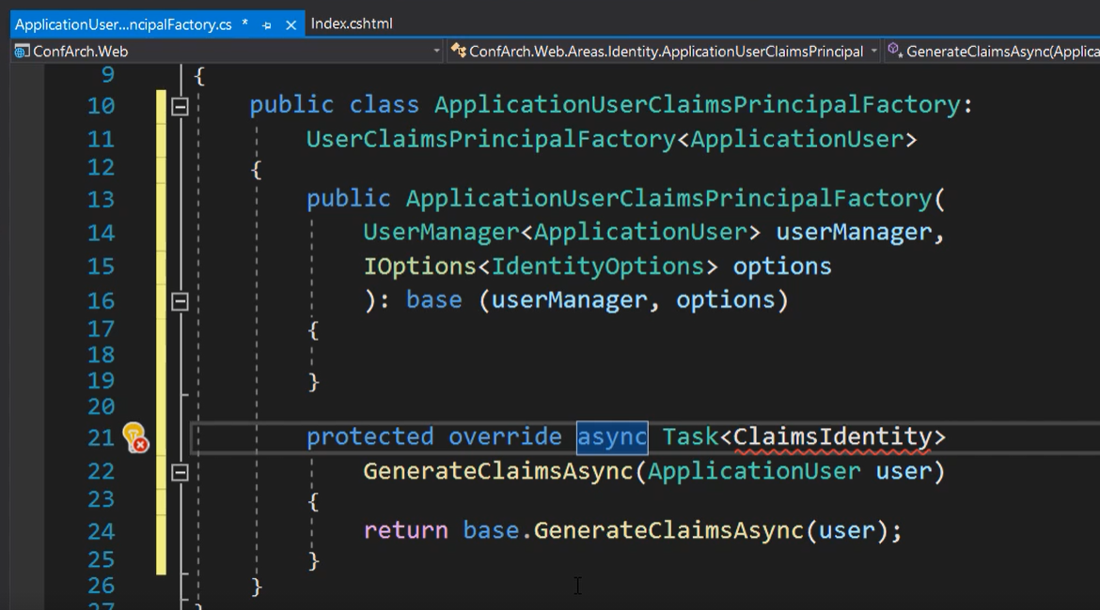

Create factory which inherit prop from user claim… with your identity

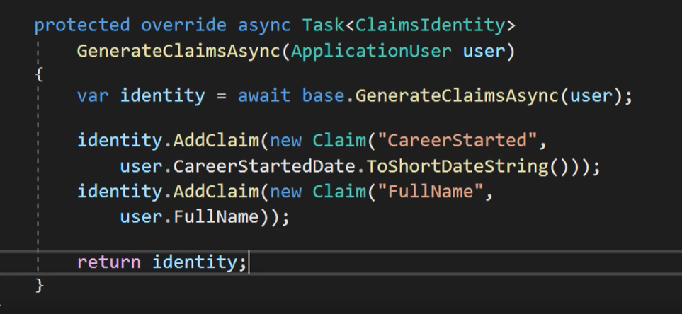

Implement your required claims and return identity.

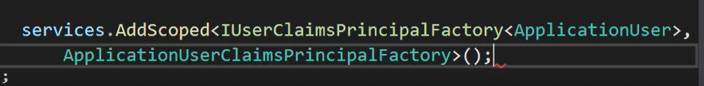

Register new class in services. New claim will be available after reboot.

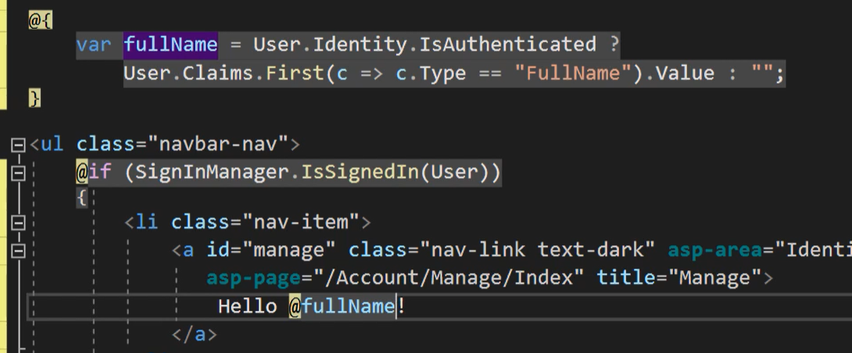

All data can be retrieved with linq instead of claims.

## Roles

Role is role is a specific purpose of user.



Add to service

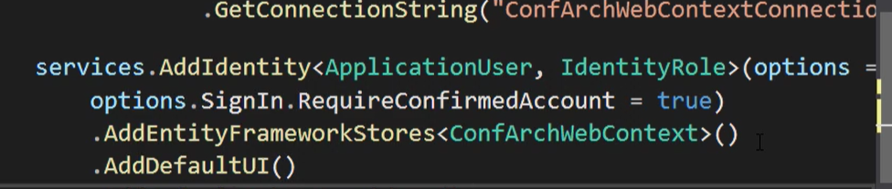

And add default UI if want

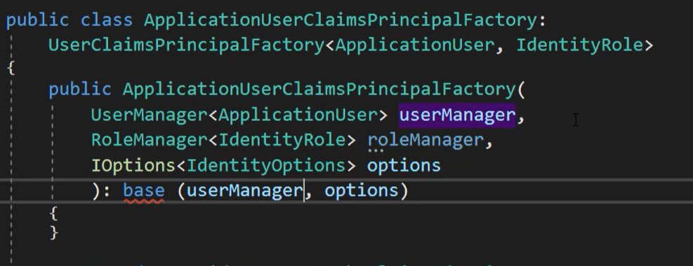

Now role manage can be added to Factory, remember adde IdentityRole

Add role manually to Db by sophisticated technique like copy past.

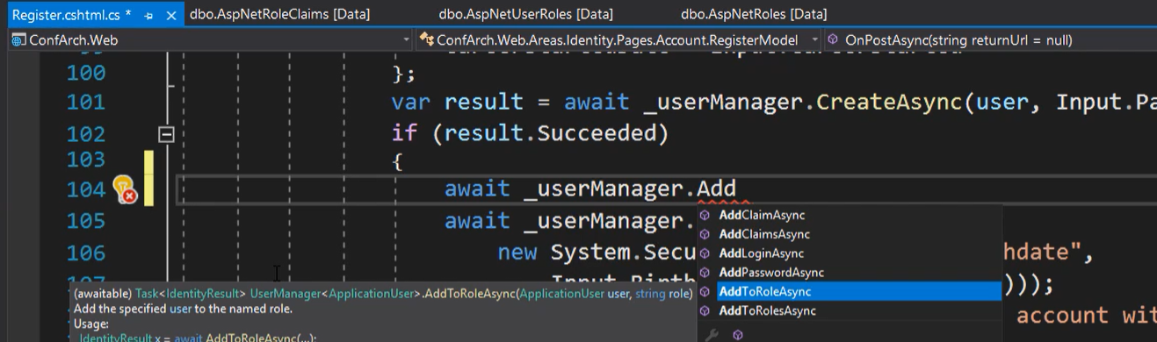

Role can be added in Register.

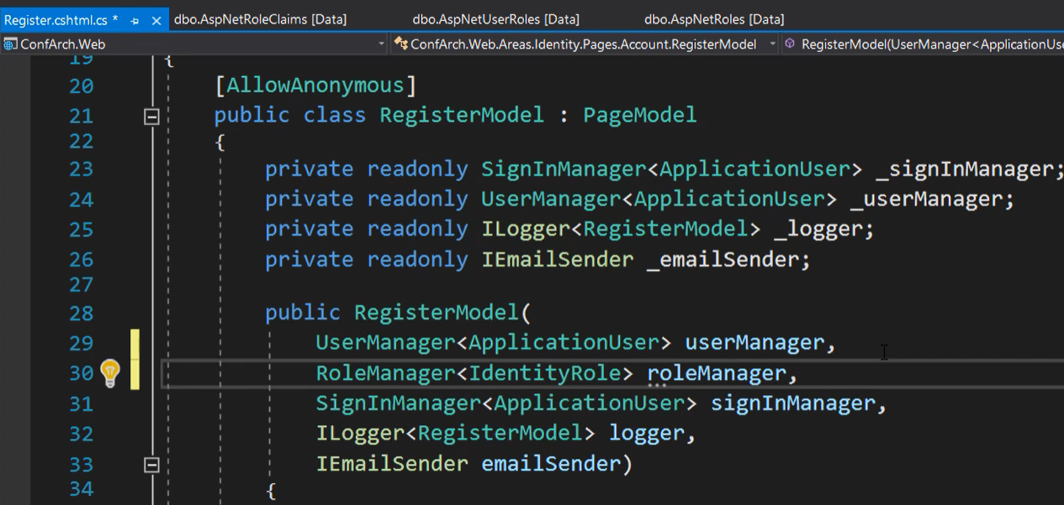

And can be use in Model.

## Email functionality

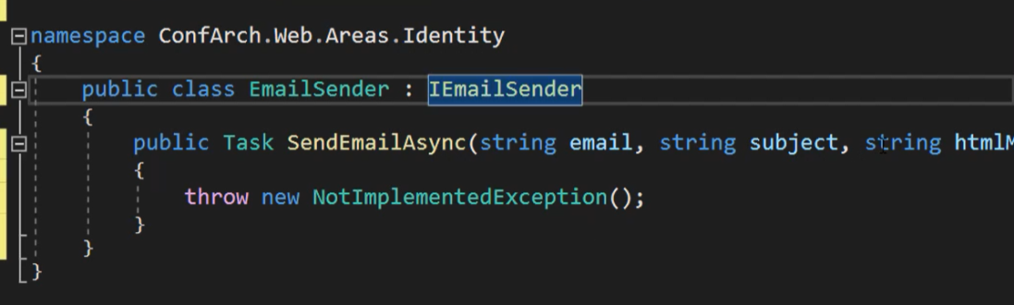

Create class in area.

Create account in SendGrid service and get your API Token, and download package SendGrid via nugget

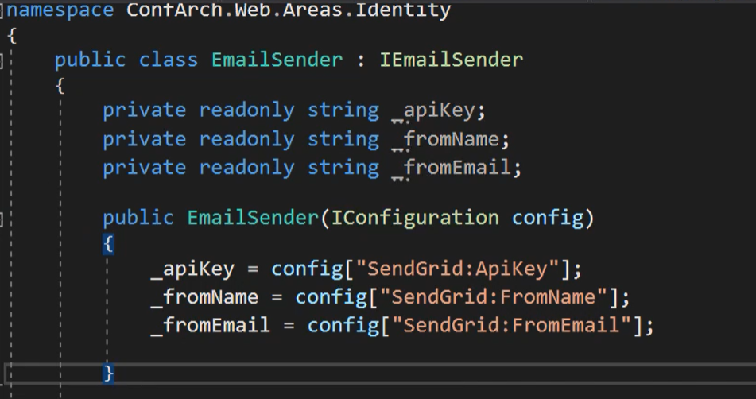

After that create three field and retrive data from config.

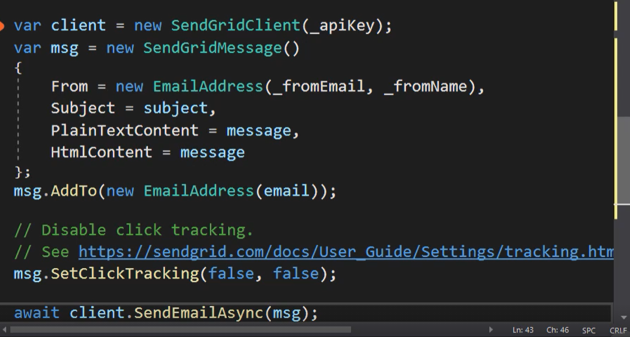

Implement method. Add client with your api. Create SendGrid message add to EmailAddress with email as param. SerClickTrack is for marketing campaigns. Last line send a message.



Register class in DI container. 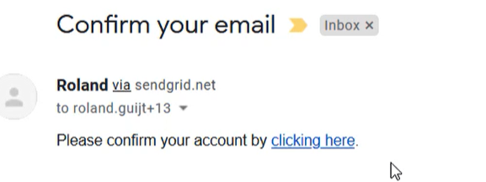

And mail was send with link to confirmation.

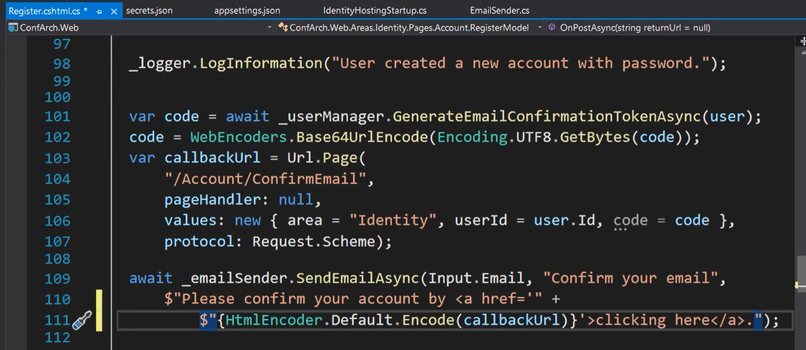

Mail is configured in Register class.

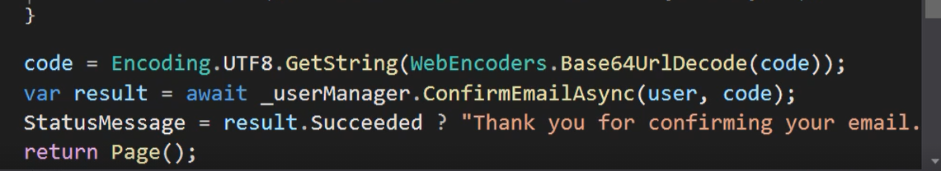

User manager send confirmation of email if user clicked on link.

## Two factor Auth